CERTIFICATE OF PARTICIPATION

Family, Career and Community
Leaders of America

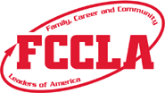

This is to recognize

whose participation in Family, Career and Community Leaders
of America exemplifies the goals and contributions of America’s youth.

President Administrator

Date Adviser

Certificate of Appreciation
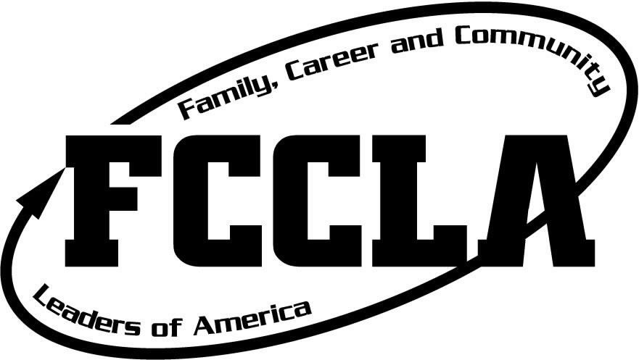

Name of Speaker

For

Inspiring us as the

Chapter FCCLA Event Keynote Speaker

Year

____________________________________________________ ________________________________________________
Officer Title Officer Title

